Program | Application Deadline | Starting Month | Cohort Size | More  Info
Case Western Reserve University  Sonya Moore, DNP APRN-CRNA FAAN FAANA  Judy Lewis, DNP APRN-CRNA  Jennifer Nicholson, DNP APRN-CRNA | June  2025 | June  2026 | 25 | 
Cleveland Clinic Foundation/  Case Western Reserve University  Angie Milosh, DNP APRN-CRNA FAANA  Ashley Showers, DNP APRN-CRNA FAANA | June  2025 | June  2026 | 25 | 
Lourdes University  Sue Rawson, DNP APRN-CRNA  Howie Brown, DNP, APRN-CRNA | March  2025 | May  2026 | 24 | 
Ohio University-Ohio Health Grant Medical Center  Kacy Ballard, DNP APRN-CRNA  Kerrie Rodgers, DNP APRN-CRNA | December  2025 | August 2026 | 25 | 
St. Elizabeth’s Health Center School for Nurse Anesthetists/ Youngstown State University  John Underwood, DNAP APRN-CRNA  Douglas Shaffer DNAP, APRN-CRNA | July  2025 | May  2026 | 20 | 
The Ohio State University  John C. Welch, DNP CRNA  Kathleen A. Piotrowski DNP APRN-CRNA, CHSE, FAANA | October  2025 | August 2026 | 20 | 
The University of Akron  Brian Radesic, MSN DNP APRN-CRNA  Sean Moore, DNP APRN-CRNA  Kaitlin Vazquez, DNP APRN-CRNA | August  2025 | June  2026 | 45 | 
The University of Cincinnati  Beth Ann Clayton, DNP APRN-CRNA FAAN FAANA  Rachel Smith-Steinert, DNP APRN-CRNA | November  2025 | January 2027 | 35 | 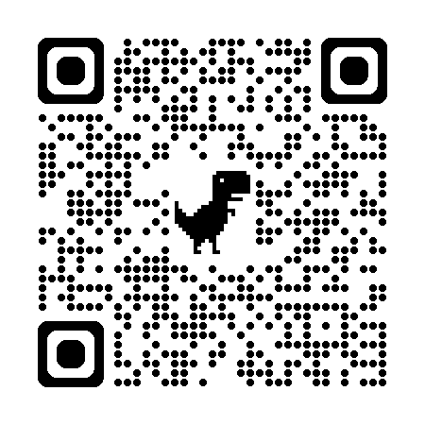
Ursuline College with SNAP  Stephanie Woodruff, DNP APRN-CRNA  Richard Wilson, DNAP APRN-CRNA  Jessica Hammond, DNAP, APRN-CRNA | April  2025 | January 2026 | 33 | 

Books
- Emotional Intelligence 2.0, by Travis Bradberry, Jean Greaves
- Make It Stick: The Science of Successful Learning, by Peter Brown, Henry Roediger, Mark McDaniel

- The Unwritten Rules of Professional Etiquette: Building A Positive Reputation in Graduate School, by Ryan Sharma
- The Truth Doesn’t have To Hurt: How to Use Criticism to Strengthen Relationships, Improve Performance, and Promote Change, by Deb Bright
- Watchful Care: A History of America’s Nurse Anesthetists, by Marianne Bankert
- Watchful Care: A History of America’s Nurse Anesthetists Volume II, by Paul Warden

AANA Membership
The American Association of Nurse Anesthesiology offers membership to RNs and APRNs. Memberships terms run from September 1-August 31 each year, and cost $250. You can find more information on the AANA website: www.aana.com. Specific benefits include:
- Online access to the AANA Journal

- CRNA advocacy/public relations
- Non-voting participation in the Annual Business Meeting
- The ability to participate in AANA committees
- Access to existing continuing education resources
- Exclusive networking events
- CRNA Education Edge learning platform
- AANA Essentials newsletter
- AANA Member Advantage Program discounts
- State association participation
- Political advocacy through CRNA-PAC

Websites
www.aana.com – The American Association of Nurse Anesthesiology
www.osana.org – The Ohio State Association of Nurse Anesthetists
www.coacrna.org – Council on Accreditation of Nurse Anesthesia Educational Programs
www.nbcrna.com – National Board of Certification & Recertification of Nurse Anesthetists
www.anesthesiafacts.com American Association of Nurse Anesthesiology Advocacy Site
https://www.apsf.org – Anesthesia Patient Safety Foundation

Podcasts
ACCRAC – Anesthesia and Critical Care Reviews
Anesthesia Deconstructed: Science. Politics. Realities.
Moving the Needle: A Nurse Anesthesiology Podcast from AANA
Anesthesia Guidebook
Beyond the Mask: Innovation & Opportunities for CRNAs
Atomic Anesthesia
ASRA News
Depth of Anesthesia
Core Anesthesia

Upcoming Events
AANA Mid Year Assembly – April 26-30 2025 – Washington DC
AANA Annual Congress – August 9-13, 2025 – Nashville TN

